是中国人的就转吧！就是点一鼠标的事。
今天日本大使来访腾讯公司。让腾讯阻止近日中国网民在网上对日本的诋毁，并骂中国人懦夫、不团结。被腾讯断然拒绝，腾讯并和小日本打了一个赌, 如果在2周内这个转发400万以上, 日本人就得向中国人道歉, 请朋友们为我们祖国加油转发吧 ！

照片解禁了,中國人的心何日解禁 ?-----永不 ! 以德報
怨,這"德"太厚了. Timothy Fu
解禁的照片
哈日嗎?
醒醒吧!
看看日本人怎麼殘害中國人,
牠們根本沒把中國人當人,
你還把牠當神嗎?
林達
解禁的照片(是中國人請轉發)
戰功圖：3歲嬰兒被用刺槍挑起
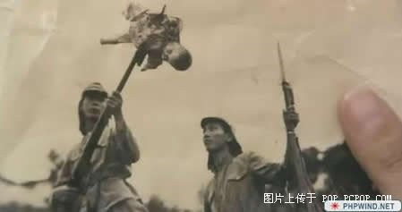
bayoneting of 3 year old baby
活着的戰士被剥光腿上的肉
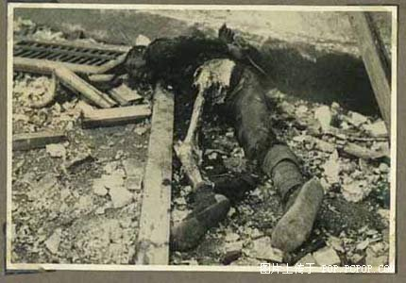
Carving out the leg muscles of a Chinese soldier
日本人殺了好多人才做到：在頭顱剛掉的一瞬間拍下
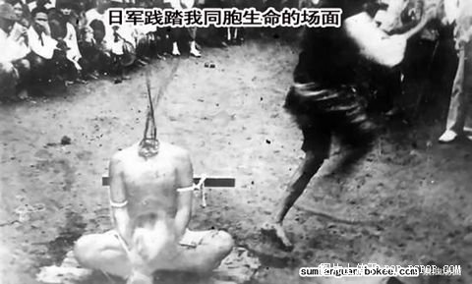
Falling off of a beheaded head. Numerous such shots had to be taken to obtain this picture母親手裏抱緊孩子。。。。可。。這能有什麼用
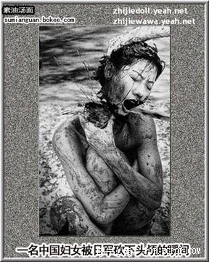
Chinese mother still clutching on her baby after her head was chopped off by Japanese soldier.
傳說中的毒氣實驗
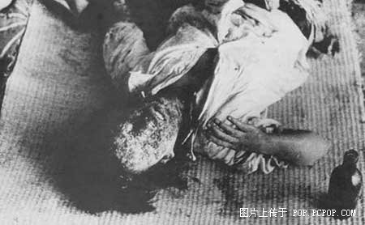
The notoriouspoisonous gas experiment
孩子有錯嗎
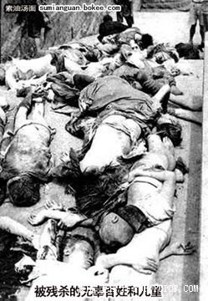
What crime had the children committed?!
我不知道還能再說什麼了
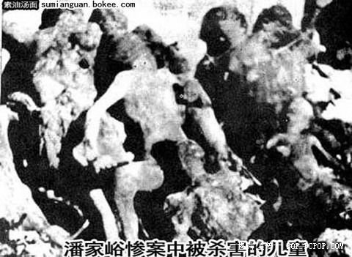
What else could I say? They were all innocent children!
人心下酒，也就日本人能喝下去。环球网论坛<http://bbs.huanqiu.com/>
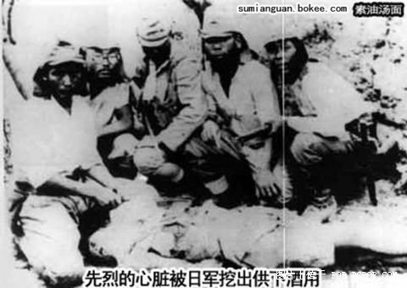
Only Japanese soldiers could wash down the heart of a martyr with sake硫酸燒人？實驗？
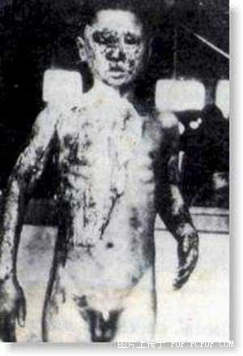
Scalding with acid. Torture? Experiment?這是個娃
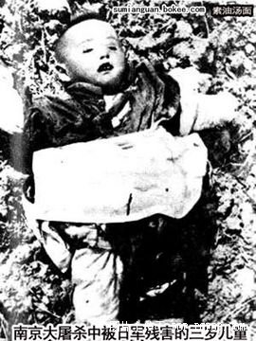
This was only a baby of three!那是腸子
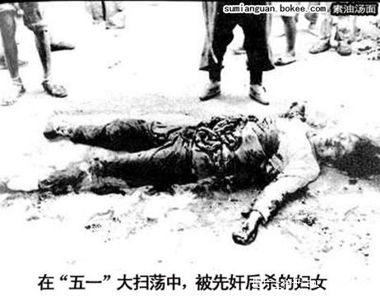
Chinese woman mutilated after raped. (intestine pulled out)
。。這是幸運的环球网论坛<http://bbs.huanqiu.com/>
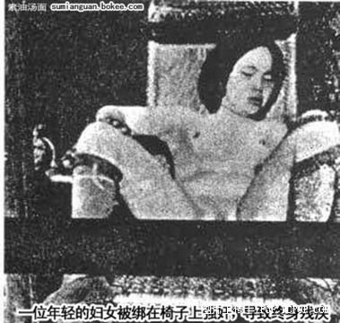
Young girl tied up & raped.
革命烈士
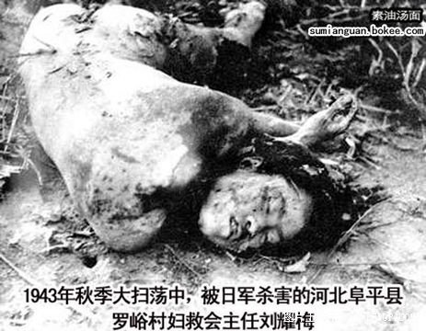
Another female martyr
懷孕多數時間以為着生命的終結
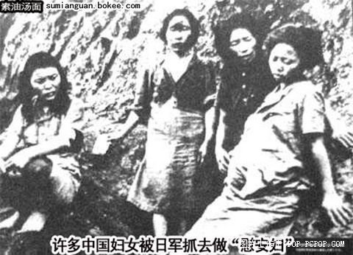
Even pregnant women were round off for army protitues
人啊！
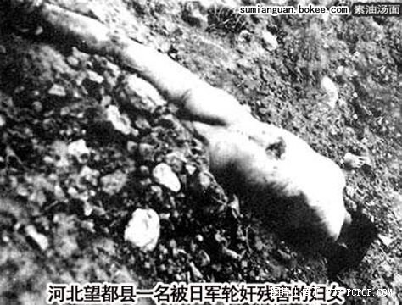
I am also a human being!!從他的微笑可以看出來。。這是這名日本兵的驕傲
但對於中國人來說。。。。
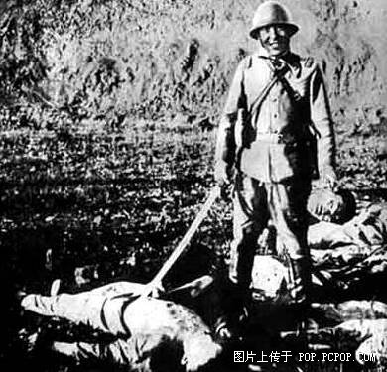
So proud of his work!
不明白為什麼那麼多中國女孩特崇拜日本明星
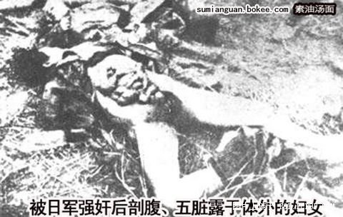
I cannot understand why young Chinese girls still crazy for Japanese actors nowadays!
無語
The proud accomplishment of the Japanese soldier!
這些可是良民，他們不相信自己會死
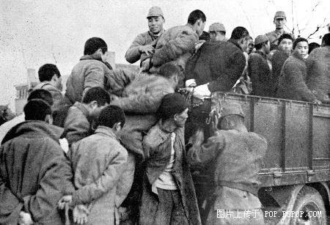
They never realized they were to be used as life targets!
良民被作為活靶子使用
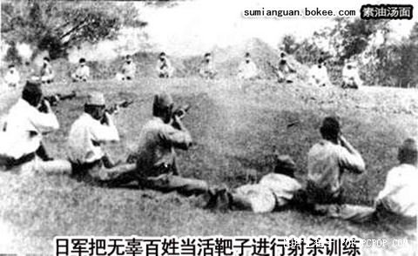
Practicing on life Chinese civilians as targets!
看，這就是武士道环球网论坛<http://bbs.huanqiu.com/>
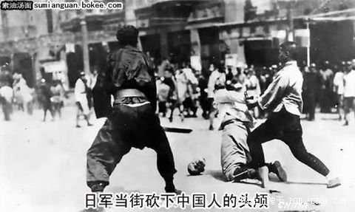
This was Japanese Bushido!
拍電影，用真人
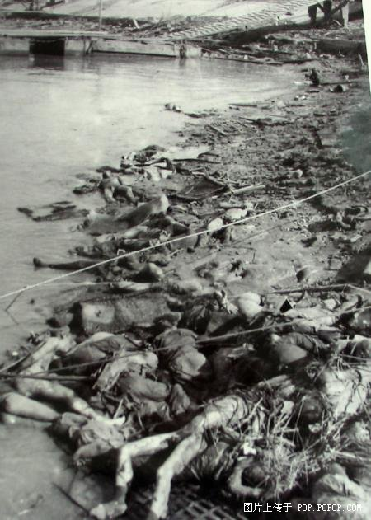
For movie scenes---use real Chinese corpses
20世紀的中國人是一種悲哀
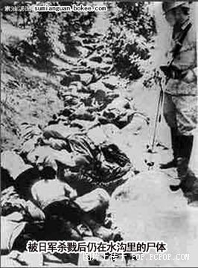
Real Chinese tragedy of the 20th century
他們的願望是：來生不是中國人！
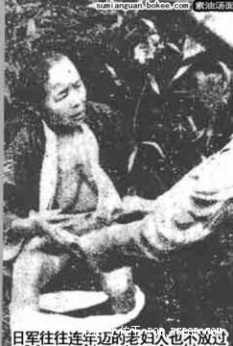
Her last wish was not to be a Chinese in her next life
你們心里在怎麼想
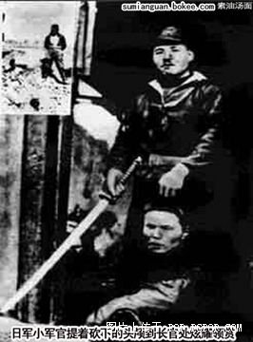
What are you thinking, soldier?
只有拿中國軍官的頭能換錢
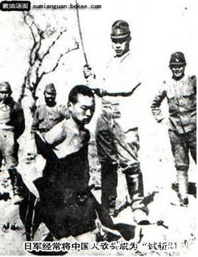
Only the head of a Chinese officer could exchange for money
朋友，别哭
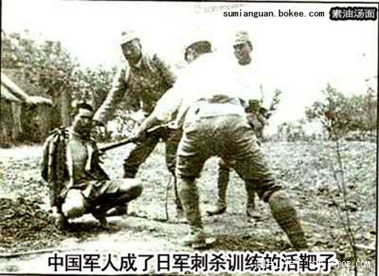
Don’t cry. This is only bayonet practice!
人頭展示1
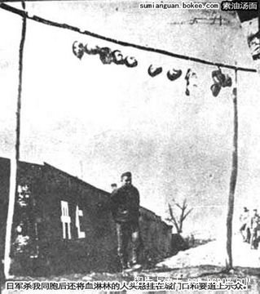
Head show 1
人頭展示2只恨我是中國人
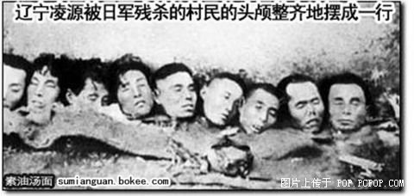
Head show 2---how I hate to be Chinese!
特寫
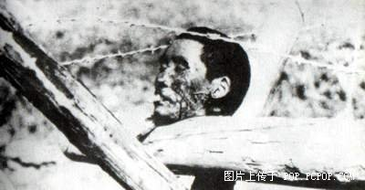
Even a cut off head could smoke?!下面那不是土，全是人
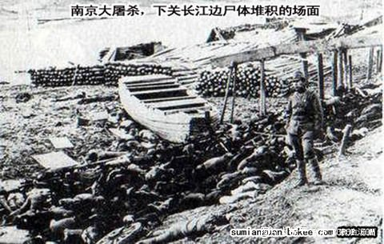
Bodies of Chinese civilians piled along the Yangtze River River當殺人成為習慣
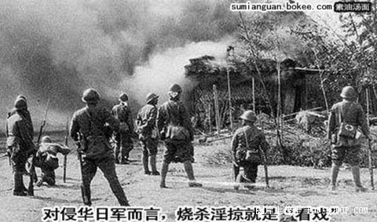
Japanese soldiers enjoyed watching kill, burn, pillage & rape他們死一萬遍够嗎？！环球网论坛<http://bbs.huanqiu.com/>
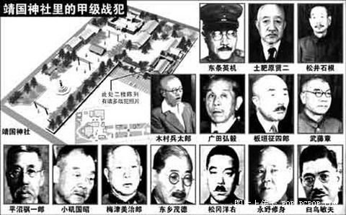
Executing these war criminals 10,000 times would not atone for their sins. In fact many Japanese nowadays still honour them as their national heroes. Until they acknowledge the war crimes of these criminals as the Germans did, the gulf between Japan & China can never be bridged!
人頭展示3
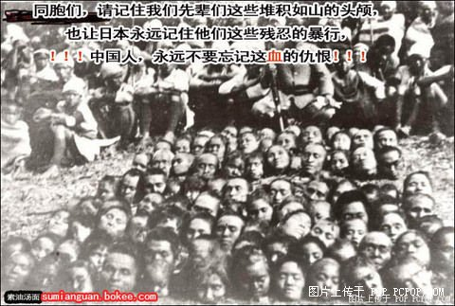
Head show 3
請大家看完後轉發給别的群體。這個没有任何獎勵。純粹是一種良知。請大家接力下去。After reading this email, please forward it to all your friends & relatives if you conscience demands it.Be sure to delete all the name list before sending out

