**地球超載日看超載超負荷的世界**

(Pictures)

[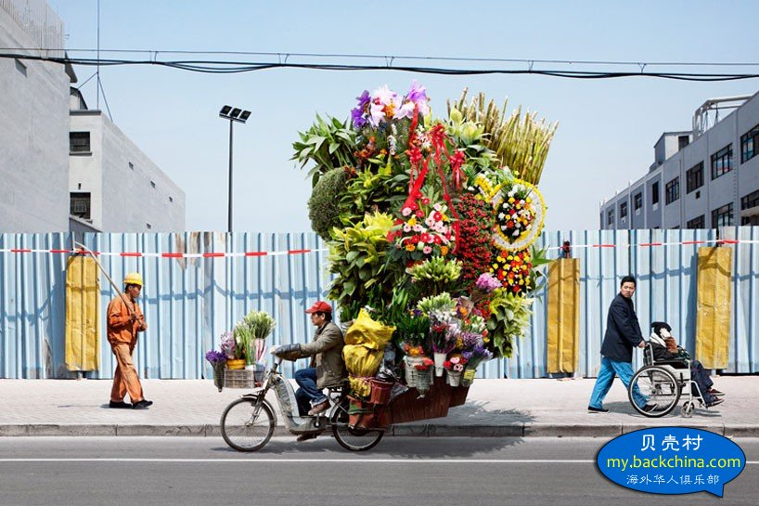](http://img.back2china.com/space/album/201508/15/004035ch35njjnosag3exx.jpg)

據說昨天是『地球超載日』,泛指人類對地球的損害,已達到地球不能再承担的程度.希望全球人類要在多方面保護地球.不要過度獲取大自然的資源.要多保育及發展再生能源.這些都是現代的老生常談......談何容易呢?

但在現实世界內,超載、超負荷却是天天發生.

法國攝影師Alain Dolorme在2009-2010年間在上海拍攝到中國物流人'雷'的程度.他文中提到這些都是升斗老百姓為了生活,挑战平衡及地心吸力.雷..雷..雷...!各位分享!

[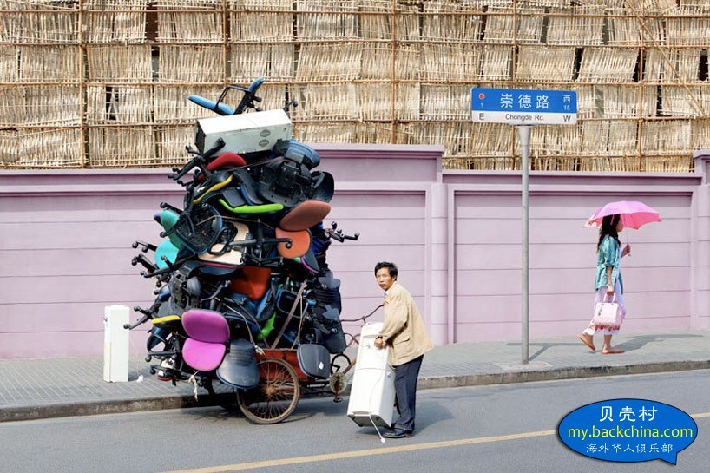](http://img.back2china.com/space/album/201508/15/004040fvzu7ssshfh7fnxu.jpg)

[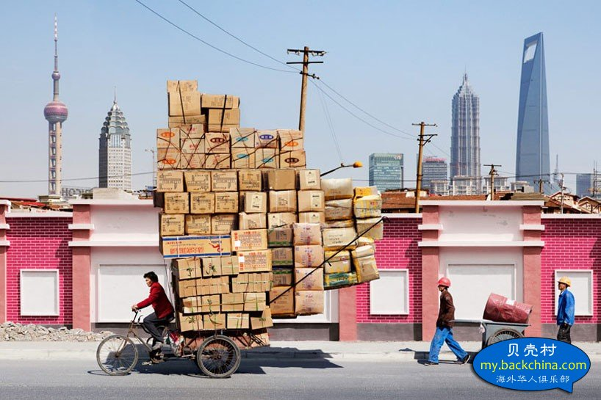](http://img.back2china.com/space/album/201508/15/004048n9y055ffhfyfyem3.jpg)

[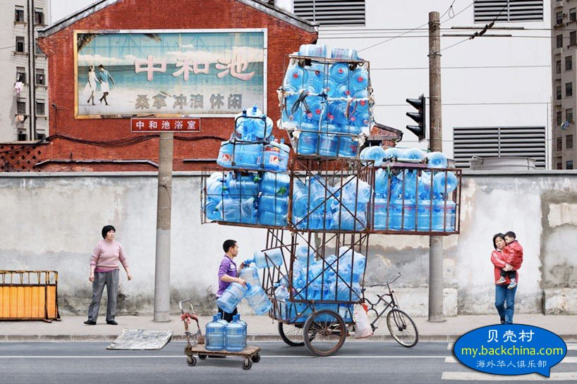](http://img.back2china.com/space/album/201508/15/004106nu8ja0dj72tz0u9i.jpg)

[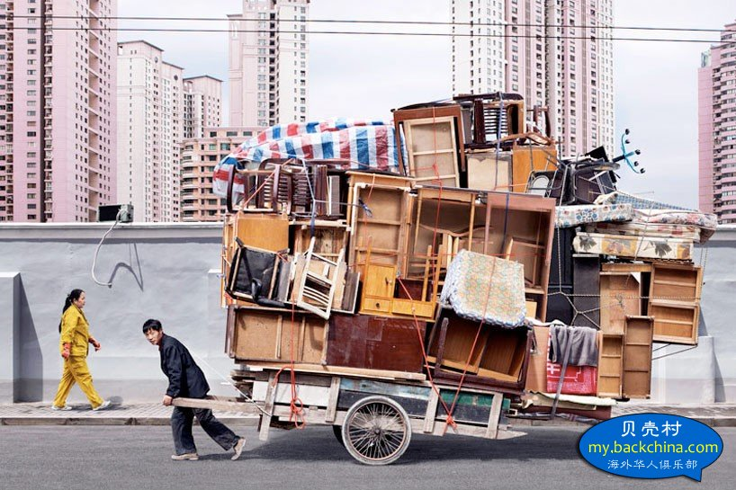](http://img.back2china.com/space/album/201508/15/004108jkexlxocc2o777xo.jpg)

[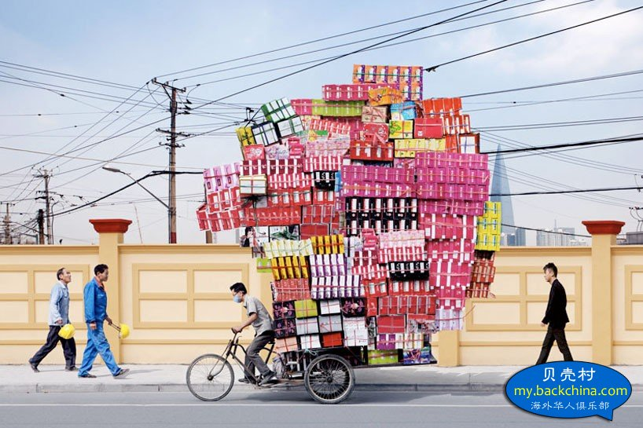](http://img.back2china.com/space/album/201508/15/004124rf7bp27eibudpuot.jpg)

[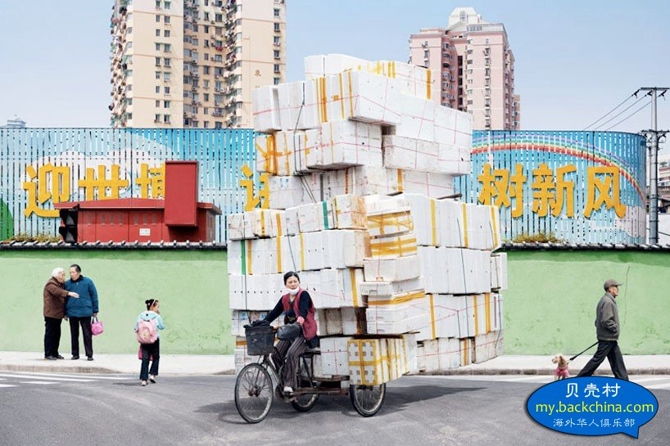](http://img.back2china.com/space/album/201508/15/004147yvcvsdicivaws4vy.jpg)

[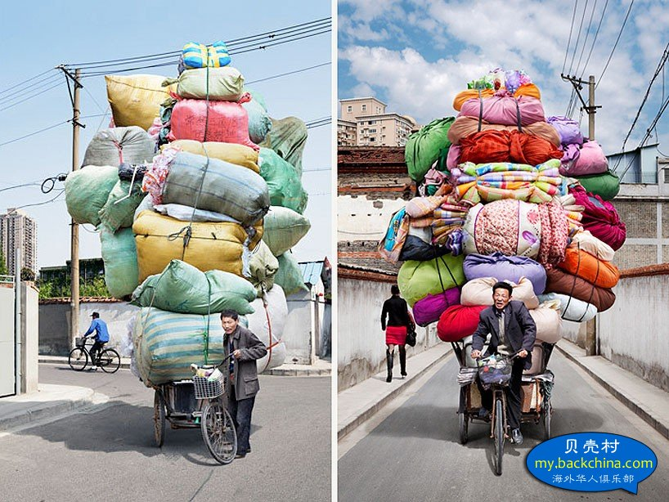](http://img.back2china.com/space/album/201508/15/004152o6n6x8ozbz8xnsoz.jpg)

[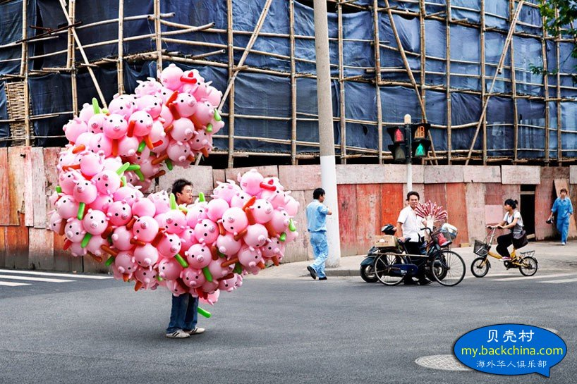](http://img.back2china.com/space/album/201508/15/004159sogoru03827r55ze.jpg)

[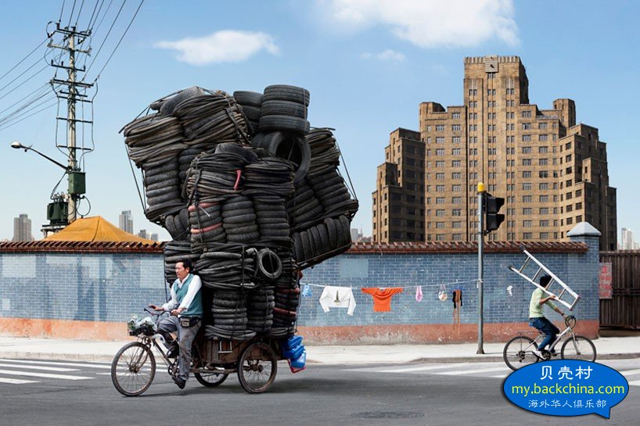](http://img.back2china.com/space/album/201508/15/004201zduk7yu7fw71115o.jpg)

我再去搜尋了一些記錄.上海的超負載還屬小巫見大巫呢.以下是一些令你看到不能相信存在的超負載.

[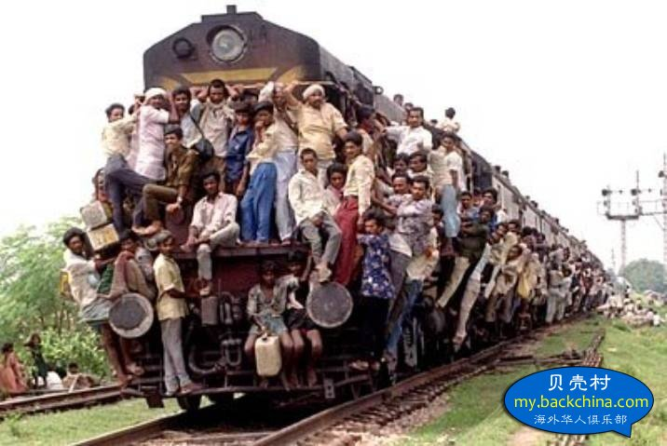](http://img.back2china.com/space/album/201508/15/004034a8ggku9wfy1nkhuc.jpg)

[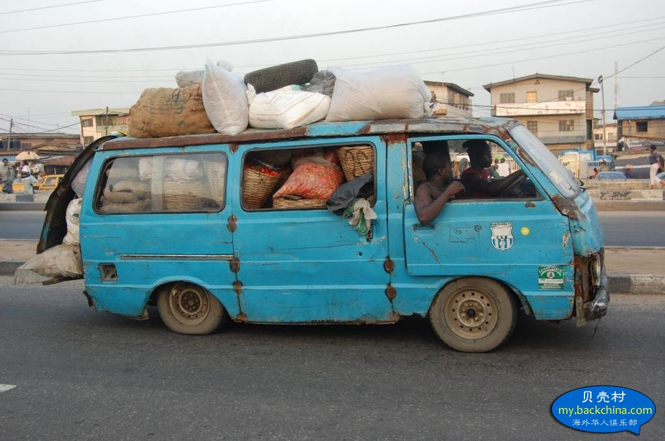](http://img.back2china.com/space/album/201508/15/004037q5l45z47e588r7t8.jpg)

[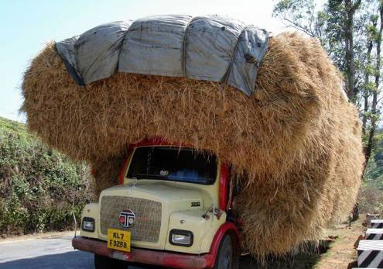](http://img.back2china.com/space/album/201508/15/004043sznxsimex6qhvh1s.jpg)

[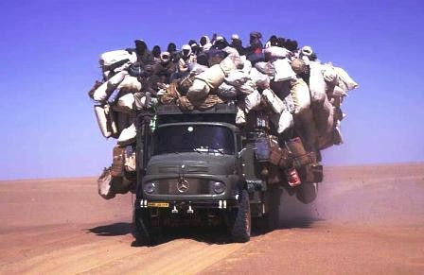](http://img.back2china.com/space/album/201508/15/004045gbzf6nnty1x21fmx.jpg)

[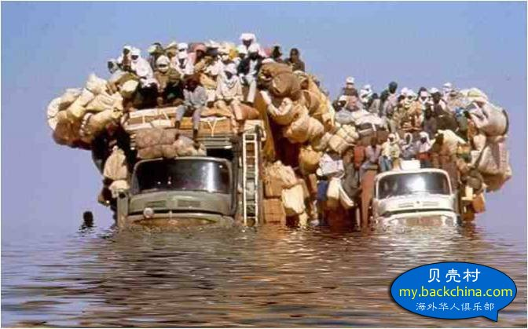](http://img.back2china.com/space/album/201508/15/004046k5hhxhuh335m5m5x.jpg)

[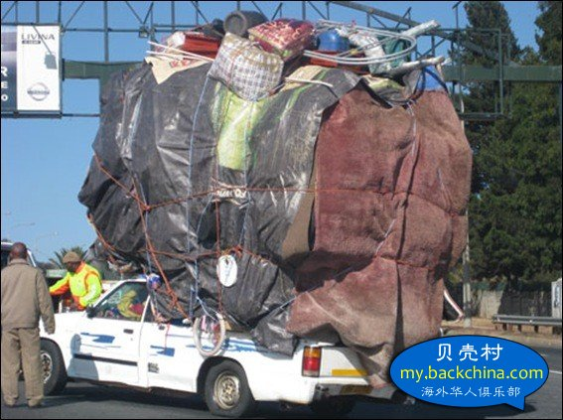](http://img.back2china.com/space/album/201508/15/004050zpmrp0rfr14p4rmp.jpg)

[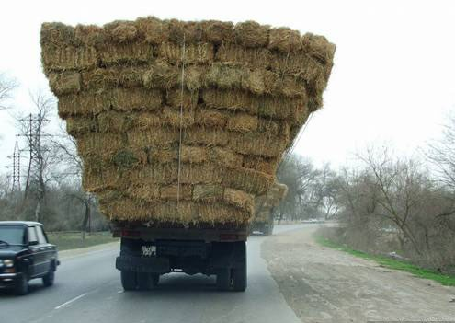](http://img.back2china.com/space/album/201508/15/004051pgamy3aamg3gqjyk.jpg)

[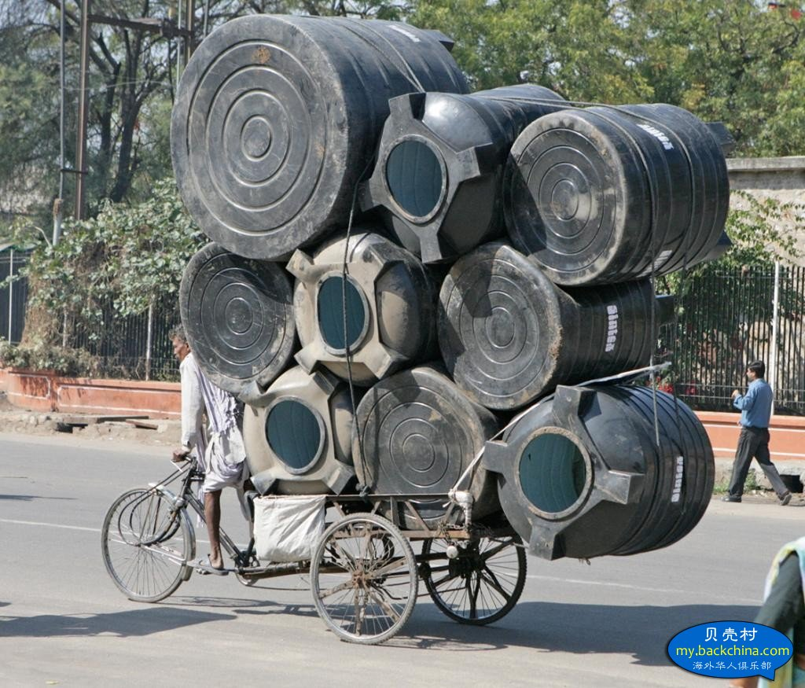](http://img.back2china.com/space/album/201508/15/004053iv0wzgiwwftqbwti.jpg)

[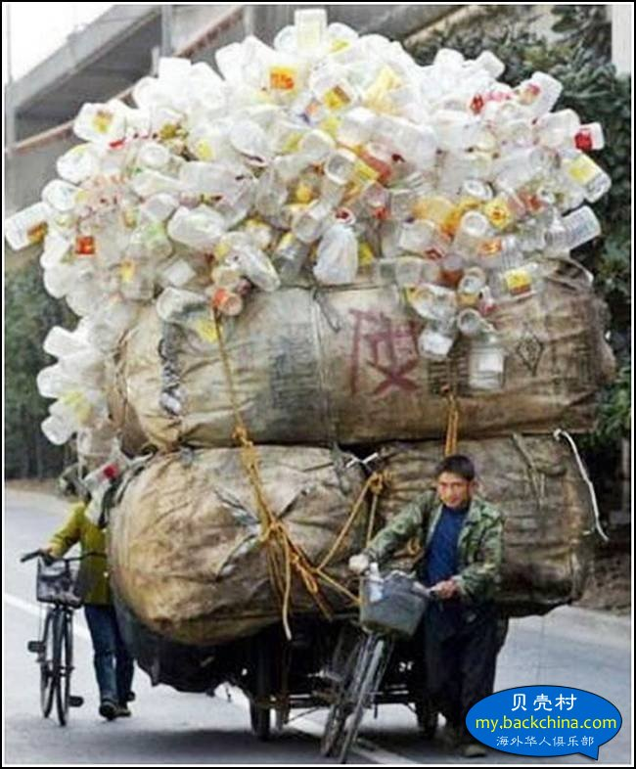](http://img.back2china.com/space/album/201508/15/004055vx1pu7cq7hscnqce.jpg)

[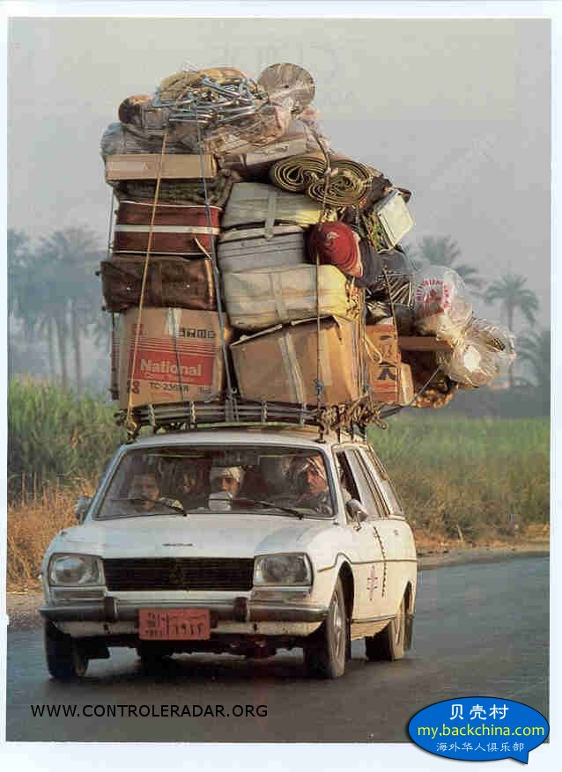](http://img.back2china.com/space/album/201508/15/004057r44k3ho2tli54f6l.jpg)

[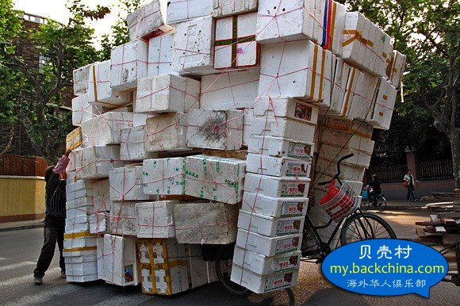](http://img.back2china.com/space/album/201508/15/004059af9mbt3dst9yswbi.jpg)

[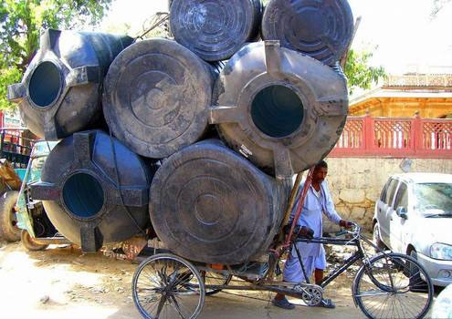](http://img.back2china.com/space/album/201508/15/004101c7d4aiwnk43laox3.jpg)

[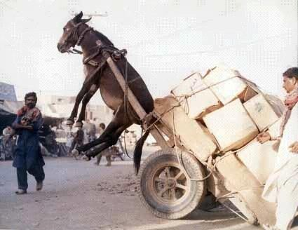](http://img.back2china.com/space/album/201508/15/004102jhigh4of323fb2h3.jpg)

[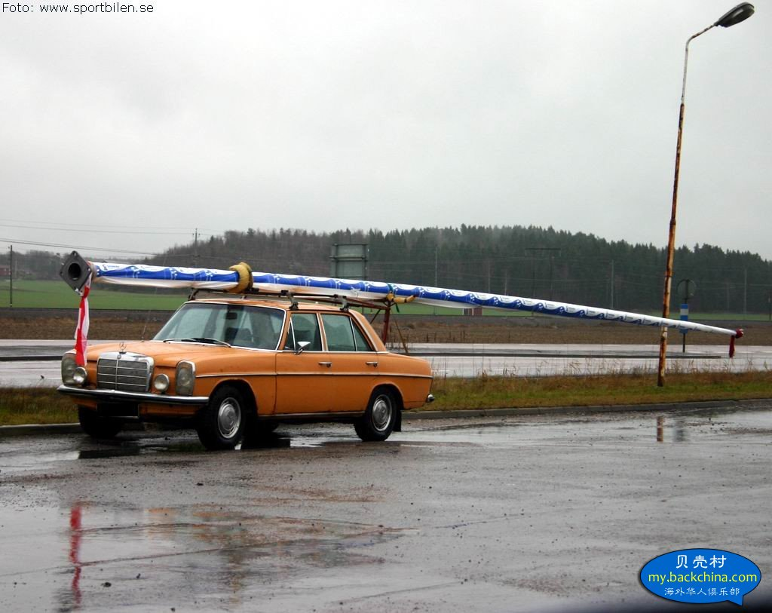](http://img.back2china.com/space/album/201508/15/004104csjyyzps8jmodmcy.jpg)

[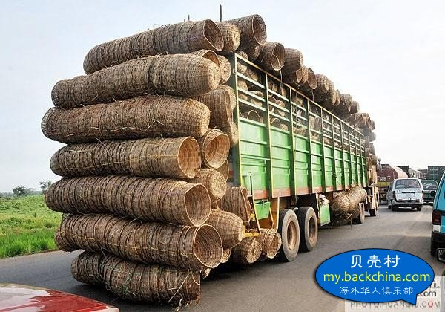](http://img.back2china.com/space/album/201508/15/004110lssaededes9ztaze.jpg)

[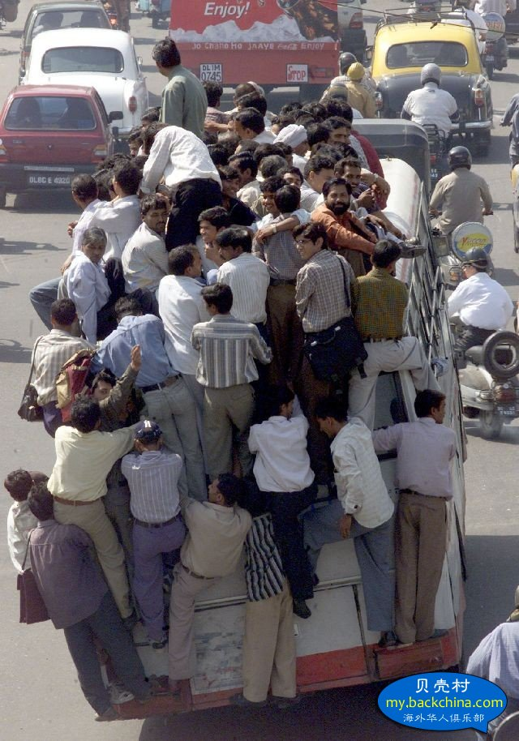](http://img.back2china.com/space/album/201508/15/004112ey4k0yco05xzn55n.jpg)

[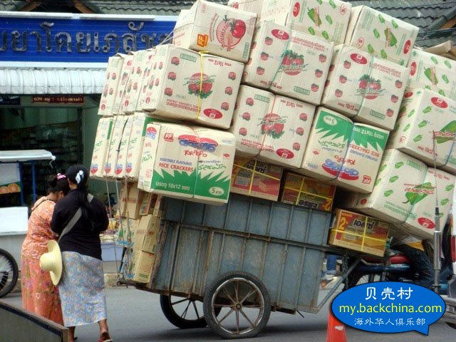](http://img.back2china.com/space/album/201508/15/004114s1yumq396a9icyeq.jpg)

[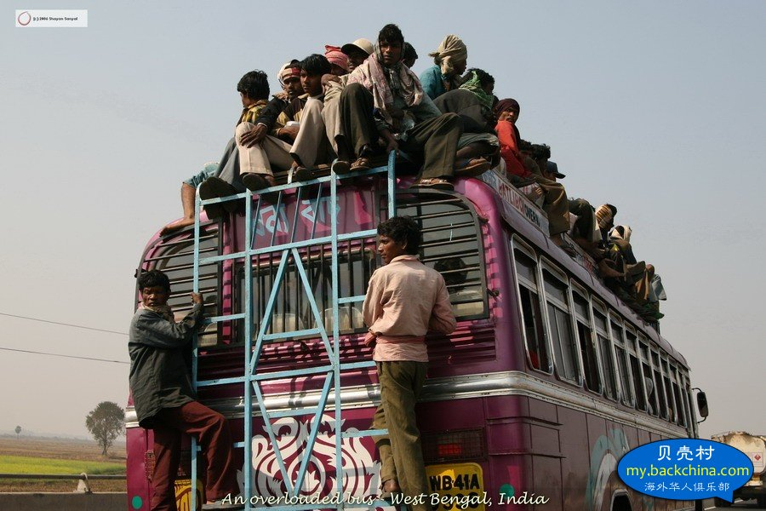](http://img.back2china.com/space/album/201508/15/004116pnbac3n4hnpjocp1.jpg)

[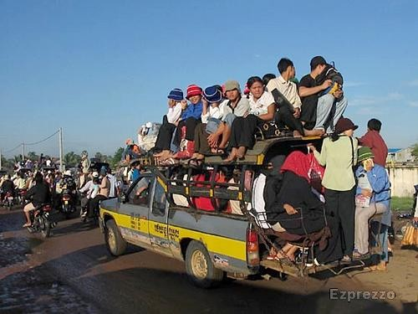](http://img.back2china.com/space/album/201508/15/004117e1n9m5pzujjlu05z.jpg)

[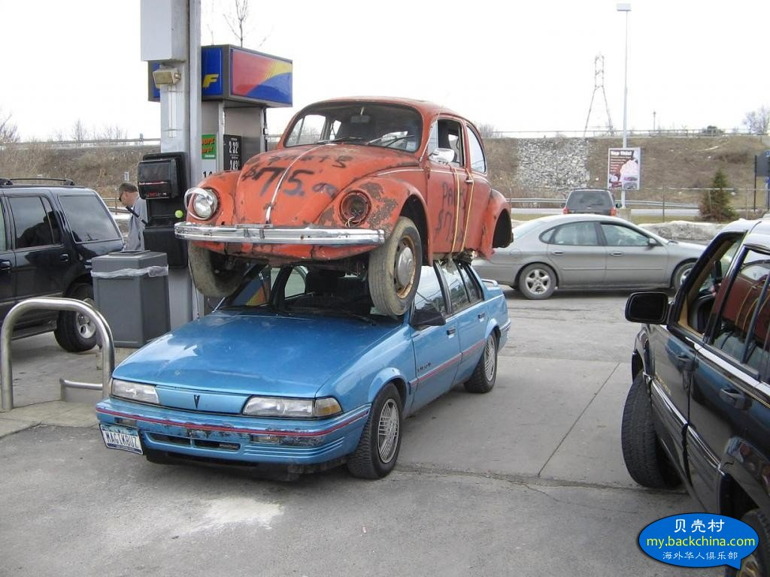](http://img.back2china.com/space/album/201508/15/004119eh4rryhop4ahymdv.jpg)

[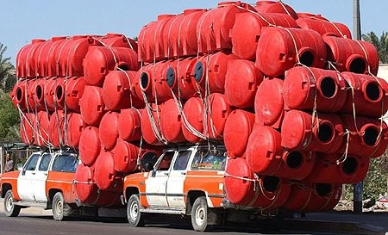](http://img.back2china.com/space/album/201508/15/004121ttlnw8ctrh0woz8i.jpg)

[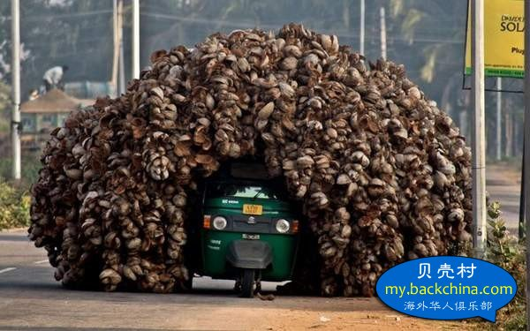](http://img.back2china.com/space/album/201508/15/004122oanaaamdbd68cea8.jpg)

[](http://img.back2china.com/space/album/201508/15/004126cugbhob5k3zbb25o.jpg)

[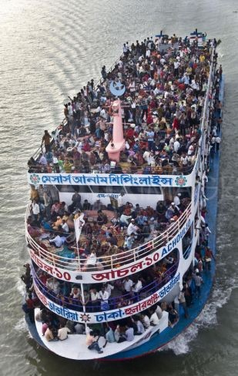](http://img.back2china.com/space/album/201508/15/004128lacwrr243pzy4c3f.jpg)

[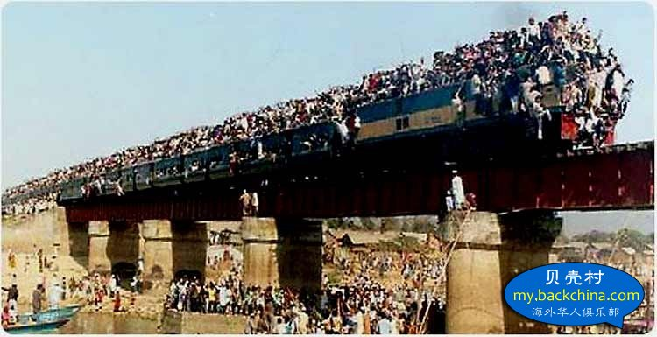](http://img.back2china.com/space/album/201508/15/004129tgejh7zjem753mpm.jpg)

[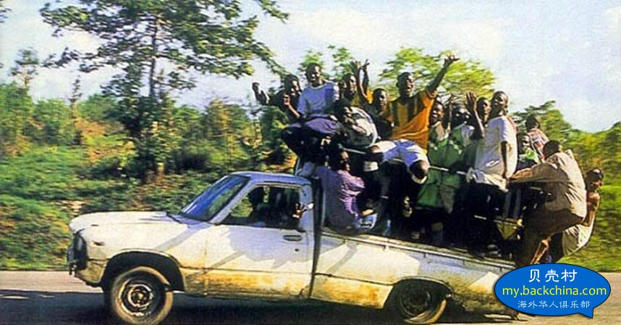](http://img.back2china.com/space/album/201508/15/004131anpjnnyyzxcbnbny.jpg)

[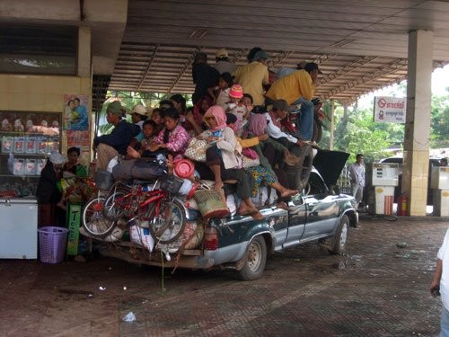](http://img.back2china.com/space/album/201508/15/004132qfutdfuflfrul27y.jpg)

[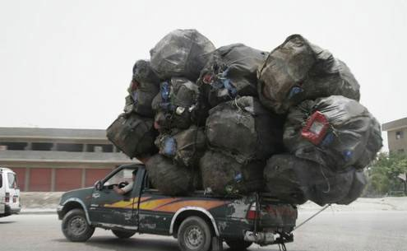](http://img.back2china.com/space/album/201508/15/004134pp0vycj5de2w5lyy.jpg)

[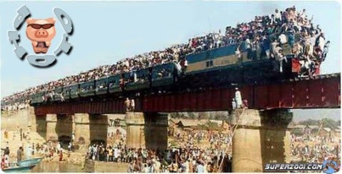](http://img.back2china.com/space/album/201508/15/004135zh5nan02aknat00b.jpg)

[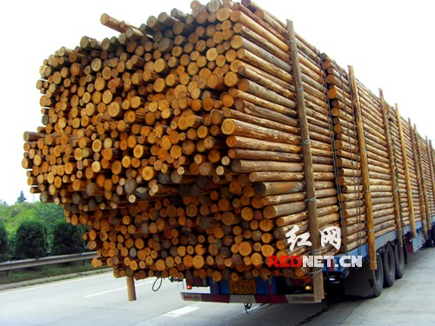](http://img.back2china.com/space/album/201508/15/004138hol9lo33jlzf3uzq.jpg)

[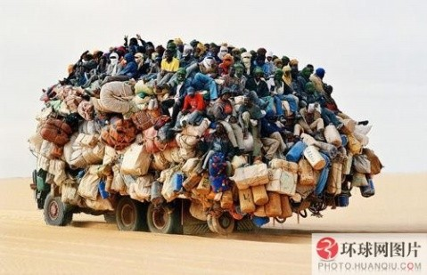](http://img.back2china.com/space/album/201508/15/004139sso07bhsh4qt0cde.jpg)

[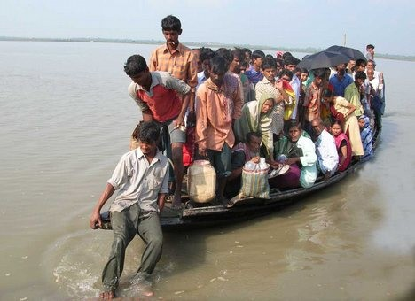](http://img.back2china.com/space/album/201508/15/004141cw1g9icowwpg1j1p.jpg)

[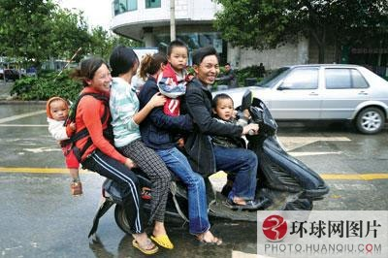](http://img.back2china.com/space/album/201508/15/004142vhwywq2gu7ykdorj.jpg)

[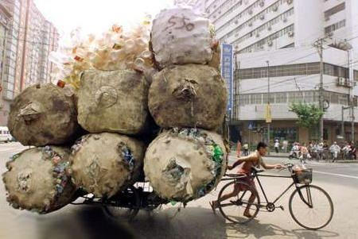](http://img.back2china.com/space/album/201508/15/004144e4h31sdst3sdodbg.jpg)

[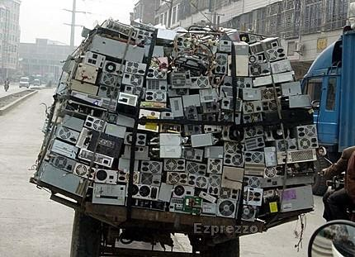](http://img.back2china.com/space/album/201508/15/004145p1sx1mr40txcsknw.jpg)

[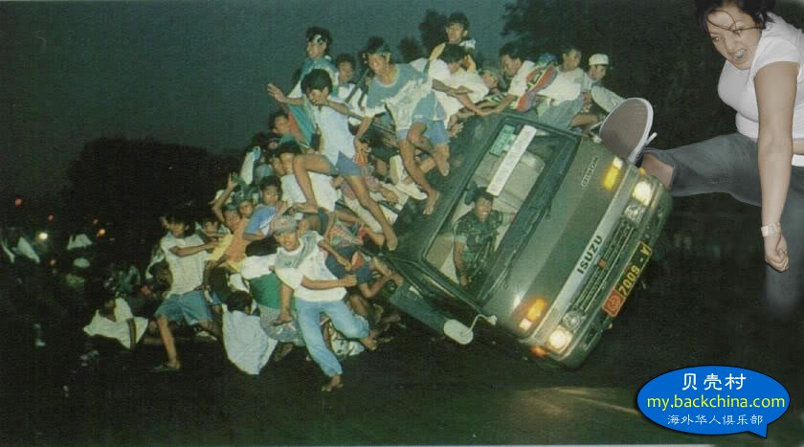](http://img.back2china.com/space/album/201508/15/004149iyzwyy3www2eraww.jpg)

[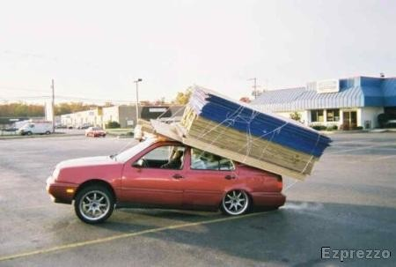](http://img.back2china.com/space/album/201508/15/004151pg0gtpygacagadvs.jpg)

[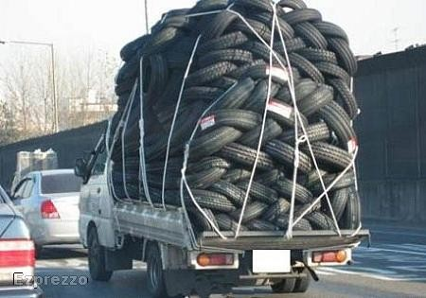](http://img.back2china.com/space/album/201508/15/004154hnvptvrtpvtvnlvv.jpg)

[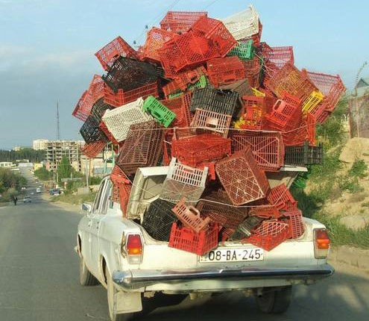](http://img.back2china.com/space/album/201508/15/004156vw4v9w7vcykz8vm2.jpg)

[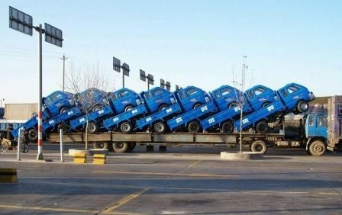](http://img.back2china.com/space/album/201508/15/004157yfalblcb7ikblf7a.jpg)

[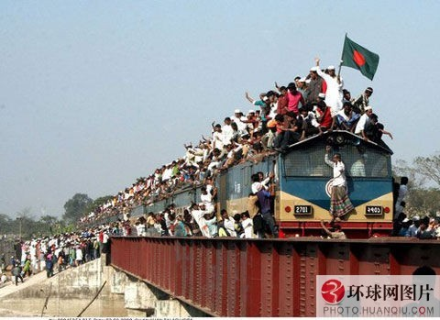](http://img.back2china.com/space/album/201508/15/004203pq5mibyvt5vjihr7.jpg)

[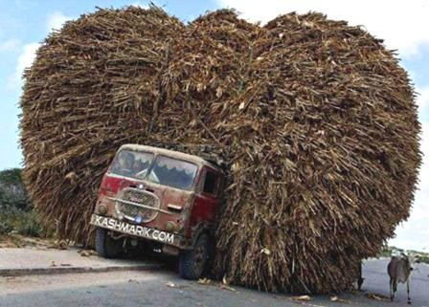](http://img.back2china.com/space/album/201508/15/004204sswwclkkhca2sg3k.jpg)



阅读详情: <http://www.backchina.com/blog/347643/article-231625.html#ixzz3itviMPhU>